Level 2 – AS91259 – 3 Credits – Internal

**2.4 Use Apply Trigonometric Relationships**

Written by Jake Wills – MathsNZ – [jwills@mathsnz.com](mailto:jwills@mathsnz.com)

|  |  |  |
| --- | --- | --- |
| **Achievement** | **Achievement with Merit** | **Achievement with Excellence** |
| Apply trigonometric relationships in solving problems. | Apply trigonometric relationships, using relational thinking, in solving problems. | Apply trigonometric relationships, using extended abstract thinking, in solving problems. |

Notes from Lesson 1: Finding Area of Triangle 2

Notes from Lesson 1.1: Introduction to Non-Right Angle Triangles 2

Notes from Lesson 2.2 2

# Notes from Lesson 1: Finding Area of Triangle

## Notes from Lesson 1.1: Introduction to Non-Right Angle Triangles

When we have a right angle triangle we label the sides using the lowercase letters a, b and c and we label the angles using uppercase letters A, B and C.

This gives us a triangle that looks like this:

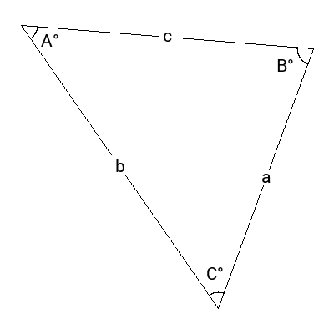

## Notes from Lesson 2.2

To find the area of a triangle you use the formula: Area = ½ a b sin(C)

As you can see from the triangle below, a and b are the two sides, and C is the angle in between them.



Let’s look at an example:



For this the formula is Area = ½ a b sin (C)

So… Area = ½ × 10 × 12 × sin(100) = 59.1m2 (don’t forget the units)